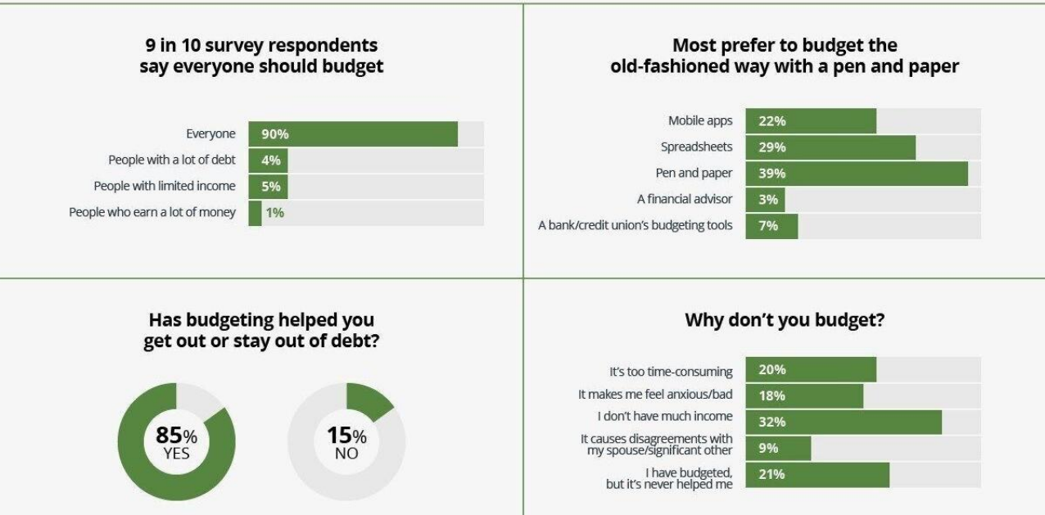

**Resource Planning**

1. Importance
2. Relationship to Schedule Planning
3. Human Resources
4. Other Resources
5. After you have created the first draft of your schedule, an important step is to identify the resources required
6. Sometimes the same resource is needed for two different tasks, so they cannot be carried out concurrently
7. Resources include
   1. Human resources
   2. Other resources such as equipment, office space, computer hardware or software, construction materials

**Relationship Between Schedule Planning and Resource Planning**

* Based on the WBS, the PM and team have prepared the initial draft of the schedule
* This is a key step
* If you don’t yet understand the scheduling part of the planning process, review it before proceeding to resource planning

**Estimating—tools and techniques**

1. Expert judgment
2. Alternative analysis
3. Published estimating data
4. Project management software
5. Bottom-up estimating

**Resource Leveling**

1. If two or more concurrent activities need to use the same resources, the schedule may need to be adjusted
2. If a very expensive piece of equipment such as a crane is required, the tasks may have to be rescheduled consecutively rather than concurrently
3. This can also happen due to staff requirements
4. Software such as MS Project has resource leveling tools

**The mythical man-month**

What is the impact of adding people to a project that is struggling to meet deadlines?

**HR Planning**

1. The most important resource is the people
2. Select the right people
   1. Technically skilled
   2. Motivated
3. Provide them with the resources and training they need
4. Nurture them—provide compensation and recognition
5. Deal with issues promptly and as directly as possible

**The person-day**

1. The work of one person for one day is a person-day
2. You may also work with person-hours
3. Think about how easy or difficult it is to substitute one person for ten days in place of ten people for one day on different tasks:
   1. Installing ten dozen new PCs on desktops in an office area
   2. Configuring the server which the PCs will use for file and print sharing
   3. Creating a new computer game
   4. Pouring a foundation
   5. Building the forms into which the foundation will be poured

**Typical project team roles**

1. Project Manager
2. Developer
3. Engineer
4. Subject matter expert
5. Team members
6. Customer/client representative

**The HR environment**

1. Laws
   1. Employment regulations such as wage legislation, holidays
   2. Health and Safety
2. Culture
3. Organizational standards
4. Collective Agreements

**Employee performance management**

1. Employee performance
   1. employee’s work results such as quality or quantity of outputs,
   2. work behaviour (such as punctuality)
   3. job-related attributes (such as cooperation and initiative)
2. After conducting employee performance reviews managers should:
   1. provide feedback to employees about how well they have performed on established goals
   2. provide feedback to employees about areas in which the subordinate is weak or could do better
   3. take corrective action to address problems with employees performing at or below the minimum expectations
   4. reward superior performers to encourage their continued excellence

**Maslow’s Hierarchy of Needs**

1. Physiological
2. Safety
3. Love/belonging
4. Esteem
5. Self-actualization

**Emotional Intelligence**

1. Self-awareness
2. Self-regulation
3. Empathy
4. Relationship management

**Personality Types**

1. Myers-Briggs: four dimensions:
   1. Extroversion <–> Introversion
   2. Sensing <–> Intuition
   3. Thinking <–> Feeling
   4. Judging <–> Perceiving
2. Sixteen personality types can be derived from the four dimensions
3. Generally, a MIX of personality types on a project brings strength
4. Knowing your own type and the types of other team members can help people work together

**Dimensions of Leadership**

1. Robert Tannenbaum and Warren Schmidt - leaders are either autocratic or democratic
2. Harold Leavitt - leaders are pathfinders (visionaries), problem solvers (analytical), or implementers (team-oriented)
3. James MacGregor Burns - leaders are either transactional (focused on actions and decisions) or transformational (focused on the long-term needs of the group and organization)
4. Fred Fiedler - contingency theory, the ability of leaders to adapt

**Negotiation**

1. A key project management skill
2. Frequently, PMs have accountability but may have limited authority
   1. Matrix management structure
   2. Subject matter experts
3. Negotiating with
   1. Other managers
   2. Suppliers
   3. Customers
   4. Others

**Conflict**

1. Conflict is not a bad thing—it can be healthy for people to be able to express differences about how to approach the work
2. Conflict-resolution styles:
   1. Avoiding
   2. Forcing
   3. Collaborating
   4. Compromising
   5. Accommodating

**Delegation**

1. PM is not expected to DO all the work
2. Must identify and clearly assign work to others on the team
3. Make expectations clear
4. Recognize performance
5. Follow through

**Resource management techniques**

Resource levelling

1. The objective is 100% utilization
2. Software can help

**Resource Planning Summary**

1. Planning for resource utilization is a key process in preparing a project plan
2. Resource planning follows the first draft of the schedule and impacts the schedule
3. Resources include human resources and other resources
4. Managing human resources includes hiring, training, motivating, rewarding
5. A number of models can be used to help the team work together
6. There are several theories of leadership; leadership is more than issuing directives